**Contacthub Integration Guide**

Version 17.1

Table of Contents

Table of Contents 2

1. Summary 4

2. Component Overview 5

2.1 Functional Overview 5

2.2 Use Cases 5

2.3 Limitations, Constraints 5

2.4 Compatibility 5

2.5 Privacy, Payment 5

2.5.1 5

3. Implementation Guide 6

3.1 Setup 6

3.1.1 Uploading the Cartridge to the sandbox. 6

3.1.2 Adding the cartridge to the cartridges path 6

3.1.3 Importing the Custom Site Preferences, Services and System Objects Extensions all together 6

3.1.4 Importing the Custom Preferences 7

3.1.5 Typing the Custom Preferences 7

3.2 Custom Code 8

3.2.1 Loading the component 8

3.3 External Interfaces 8

3.4 Testing 8

4. Operations, Maintenance 9

4.1 Data Storage 9

4.2 Availability 9

4.3 Support 9

5. User Guide 10

5.1 Roles, Responsibilities 10

5.2 Business Manager 10

5.3 Storefront Functionality 10

6. Known Issues 11

7. Release History 11

# Summary

# Component Overview

## Functional Overview

## Use Cases

## Limitations, Constraints

## Compatibility

Cartridge designed for Demandware API version 17.1.

## Privacy, Payment

### 

# Implementation Guide

## Setup

### Uploading the Cartridge to the sandbox.

Please follow the following steps to install the cartridge on your sandbox:

1. Open Demandware Studio.
2. Click File -> Import -> General -> Existing Projects Into Workspace.
3. Browse to the “contacthub_cartridge” folder.
4. Click finish.
5. Click OK when prompted to link the cartridge to your sandbox.

### Adding the cartridge to the cartridges path

Add the Contacthub cartridge by the following steps:

1. Log in the Business Manager.
2. Select your site in the Administration -> Sites -> Manage Sites menu.
3. Select the “Settings” tab.
4. Add “contacthub_cartridge:” (without quotes) to the Cartridges field.

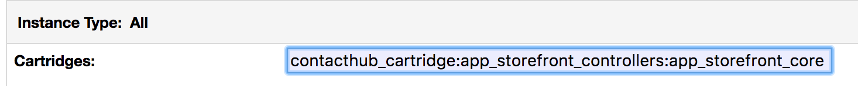

1. Click Apply.

### Importing the Custom Site Preferences, Services and System Objects Extensions all together

1. In the Business Manager, click on Administration -> Site Development -> Site Import & Export.
2. In the Import section, upload the “site-import.zip” included in the cartridge.

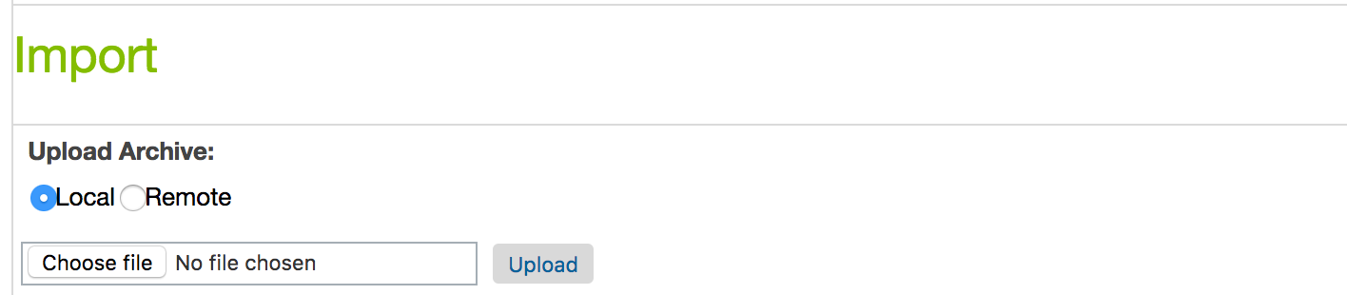

1. Select “site-import.zip” in the list and click “Import”.
2. Click “Ok”.

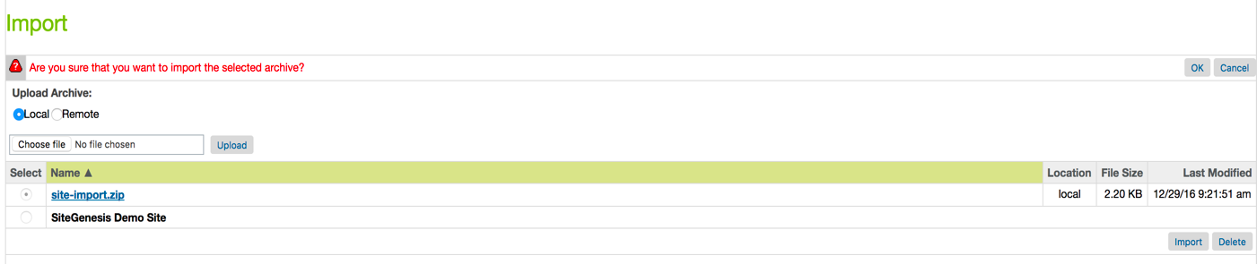

### Importing the Custom Preferences

Note: you will only need this step if your site is not named SiteGenesis.

1. TDB

### Typing the Custom Preferences

1. From the Business Manager, click on Merchant Tools -> Site Preferences.
2. Select ContactLabHubConfigs.

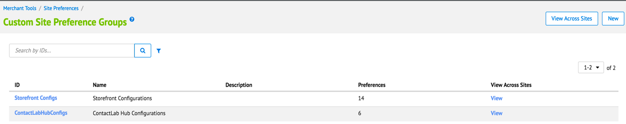

1. Fill in your data.

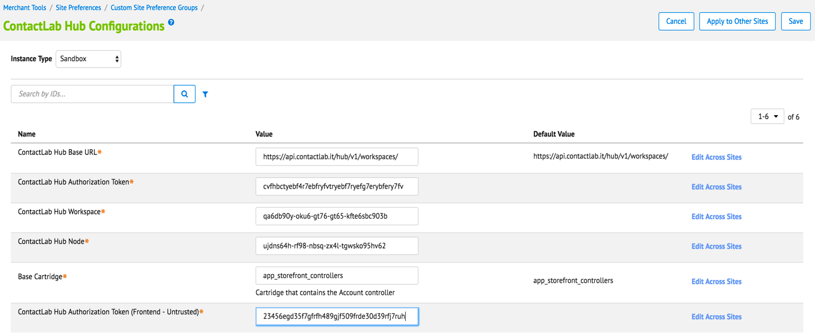

1. Click Save.

## Custom Code

### Loading the component

Paste this single line in the <cartridge_name>/cartridge/templates/default/components/footer/footer_UI.isml template file:

<isinclude template=*"contacthub/contacthub"* />

## External Interfaces

The cartridge connects to Contacthub using the Contacthub API.

## Testing

# Operations, Maintenance

## Data Storage

All data is stored on the Contacthub servers. The workspace ID, node ID, the trusted and untrusted tokens are stored as custom site preferences within SFCC.

## Availability

## Support

# User Guide

## Roles, Responsibilities

## Business Manager

Site import is described in section 3.1.3.

Template customization in 3.2.1.

## Storefront Functionality

The features offered to the customers should be transparent on the Storefront. The customers will receive emails based on their navigation and preferences.

# Known Issues

Intentionally left blank.

# Release History

|  |  |  |
| --- | --- | --- |
| **Version** | **Date** | **Changes** |
| 17.1.0 | 30/12/2016 | Initial release |